
Marine script User Manual

Nov 2009
Version 9.0.0

Contents

1. To run the Marine Script 4
1.1. Run from Custom Viewpoint Toolbar 4
1.2. Pre-requisites to starting the Marine Script. 4
1.3. Assumptions 4
2. Messages returned by the Marine Script,when run from Custom Viewpoint Toolbar 5
2.1. Please specify or select an excel sheet to proceed 5
2.2. The specified excel sheet is invalid / corrupt or does not exist at the specified path. Please check the filename or path and try again 5
2.3. Please add at least one passenger to proceed 5
2.4. Please specify a Surname to proceed 6
2.5. Please specify a First Name to proceed 6
2.6. Please specify a Vessel to proceed 7
2.7. Please specify a value for the selected Remark field or uncheck the check box 7
2.8. Please specify a valid email address to proceed 7
2.9. Please add at least one flight segment to proceed 8
2.10. You have not specified a value for a flight segment. Please specify a value to proceed 8
2.11. Please specify a valid DATE to proceed 8
2.12. Please specify a value for City to proceed 9
2.13. Please specify a value for Agent to proceed 9
2.14. Please specify a value for Consultant to proceed 9
2.15. Please specify a value for Telephone to proceed 10
2.16. Please specify a valid Date for TAU to proceed 10
2.17. Please specify a valid Date for Booking Review Date to proceed 11
2.18. Please specify a valid Date for Retention Line Date to proceed 11
2.19. City, Agent, Consultant and Telephone together cannot be greater than 51 characters. 11
2.20. Command:<%Command description%> 12
Error message :<%Host response lines.%> 12
3. Functionality details of the Marine Script 13
3.1. Select No. of Passengers and Information Source Screen/Form 13
3.2. Select Excel Template screen/form 15
3.3. Passenger and Contact Information– Single Passenger screen/form 17
3.4. Passenger and Contact Information– Multi Passenger screen/form 20
3.5. Flight Segment Information screen/form 23
3.6. Agent Contact and Ticket Deadline screen/form 25
3.7. End Transaction or Ignore screen/form 27
4. Appendix 29
4.1. Mandatory Marine data 29

To run the Marine Script

The Marine script enables the agents to directly populate data from a standard excel template into a data mask and create a booking file based on it. The script reads information like Passenger Surname, First name, Vessel name and Sea contact from the standardized excel template and adds it to the booking file.

The script also allows the agents to manually enter the information in the data mask which will automatically be added to the booking file.

User can execute the Marine script:

1) Via the Custom Toolbar button in the custom viewpoint toolbar.

  - Run from Custom Viewpoint Toolbar

After installing the Marine Script (refer to the Installation manual), a new icon (refer Figure 1) will be added in the Viewpoint Custom Toolbar of the Galileo Desktop.

To run the Marine Script via the Custom Viewpoint Toolbar button,

- Sign into the Galileo Desktop
- Then click on the Marine Script icon to run the Marine Script.

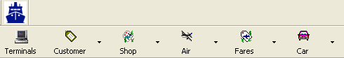
Figure 1
  - Pre-requisites to start the Marine Script:
- Galileo Desktop 1.0 or Galileo Desktop 2.x should be installed on the system.
- The user should be signed in to Galileo Desktop.
- MS Excel should be installed on the system.

  - Assumptions
- The Excel Template will be standard across all agencies. Any change in the Excel Template will require a change in the configuration of the Marine Script before it (the updated Excel Template) can be used.
- The Excel Template to be used as Template should be “MS Excel 97 to MS Excel 2003/2007 & 5.0/95 Workbook” compatible.rkbook” compatible.

Messages returned by the Marine Script when run from Custom Viewpoint Toolbar
  - Please specify or select an excel sheet to proceed
This message is displayed when the user clicks on the “Next >” button of “Select Excel Template” form and the “Filename :” text box is blank,

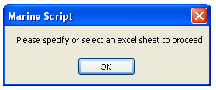
Figure 2
Click the “OK” button to close the message window.

  - The specified excel sheet is invalid / corrupt or does not exist at the specified path. Please check the filename or path and try again

This message is displayed when the user clicks on the “Next >” button of “Select Excel Template” screen or form if the “Filename :” text box is invalid or the file does not exist or the application is not able to open the file.

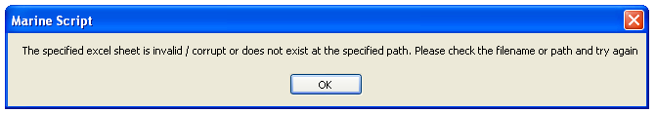
Figure 3

Click the “OK” button to close the message window and exit the application.
  - Please add at least one passenger to proceed

This message is displayed when the user clicks on the “Next >” button of “Passenger and Contact Information-– Multi passenger” screen if there is no check box for any passenger ticked.

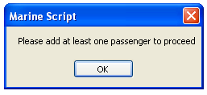
Figure 4

Click the “OK” button to close the message window.

  - Please specify a Surname to proceed

This message is displayed when the user clicks on the “Next >” button of “Passenger and Contact Information– Single passenger” screen/form or “Passenger and Contact Information– Multi passenger” screen/form if the “Surname” text box is blank.

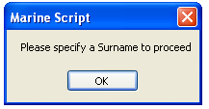
Figure 5

Click the “OK” button to close the message window.

  - Please specify a First Name to proceed

This message is displayed when the user clicks on the “Next >” button of “Passenger and Contact Information– Single passenger” screen/form or “Passenger and Contact Information– Multi passenger” screen/form if the “First Name” text box is blank.

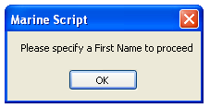
Figure 6

Click the “OK” button to close the message window.

  - Please specify a Vessel to proceed

This message is displayed when the user clicks on the “Next >” button of “Passenger and Contact Information– Single passenger” screen/form or “Passenger and Contact Information– Multi passenger” screen/form if the “Vessel” text box is blank.

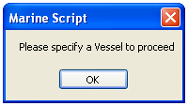
Figure 7

Click the “OK” button to close the message window.
  - Please specify a value for the selected Remark field or uncheck the check box

This message is displayed when the user clicks on the “Next >” button of “Passenger and Contact Information– Single passenger” screen/form or “Passenger and Contact Information– Multi passenger” screen/form if the check box for any of the Remark field is checked and the remark field is blank.

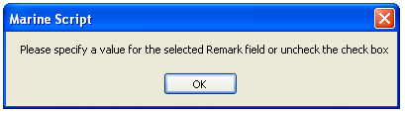
Figure 8

Click the “OK” button to close the message window.
  - Please specify a valid email address to proceed

This message is displayed when the user clicks on the “Next >” button of “Passenger and Contact Information– Single passenger” screen/form or “Passenger and Contact Information– Multi passenger” screen/form and there is an invalid value in the “Email1” or “Email2” text box. It means the symbols “@” and “.” are missing in the email address.

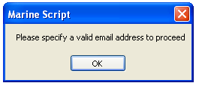
Figure 9

Click the “OK” button to close the message window.
  - Please add at least one flight segment to proceed

This message is displayed when the user clicks on the “Next >” button of “Flight Segment Information” screen/form, if there is no check box for any Flight checked.

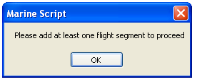
Figure 10

Click the “OK” button to close the message window.
  - You have not specified a value for a flight segment. Please specify a value to proceed
This message is displayed when the user clicks on the “Next >” button of “Flight Segment Information” screen/form, if the corresponding “YY” / “FLT”/ “CLS” / “DATE” / “OAC” / “DAC” text box is blank for all check box.

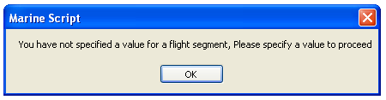
Figure 11

Click the “OK” button to close the message window.
  - Please specify a valid DATE to proceed

This message is displayed when the user clicks on the “Next >” button of “Flight Segment Information” screen/form, if the corresponding “DATE” text box does not contain a valid date or is not in the DDMMM format for every check box.

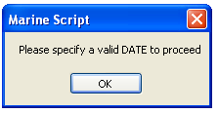
Figure 12

Click the “OK” button to close the message window.

  - Please specify a value for City to proceed

This message is displayed when the user clicks on the “Next >” button of “Agent Contact and Ticket Deadline” screen/form, if the “City” text box is blank.

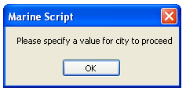
Figure 13

Click the “OK” button to close the message window.
  - Please specify a value for Agent to proceed

This message is displayed when the user clicks on the “Next >” button of “Agent Contact and Ticket Deadline” screen/form, if the “Agent” text box is blank,

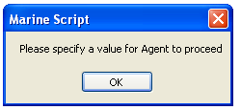
Figure 14

Click the “OK” button to close the message window.
  - Please specify a value for Consultant to proceed

This message is displayed when the user clicks on the “Next >” button of “Agent Contact and Ticket Deadline” screen/form, if the “Consultant” text box is blank.

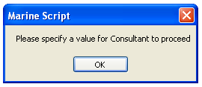
Figure 15

Click the “OK” button to close the message window.
  - Please specify a value for Telephone to proceed

This message is displayed when the user clicks on the “Next >” button of “Agent Contact and Ticket Deadline” screen/form, if the “Telephone” text box is blank.

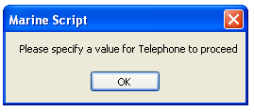
Figure 16

Click the “OK” button to close the message window.
  - Please specify a valid Date for TAU to proceed

This message is displayed when the user clicks on the “Next >” button of “Agent Contact and Ticket Deadline” screen/form, if the “TAU” text box is blank, or does not contain a valid date, or is not in the DDMMM format.

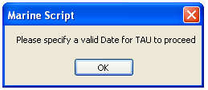
Figure 17

Click the “OK” button to close the message window.
  - Please specify a valid Date for Booking Review Date to proceed

This message is displayed when the user clicks on the “Next >” button of “Agent Contact and Ticket Deadline” screen/form, if the “Booking Review Date” text box is blank, or does not contain a valid date, or is not in the DDMMM format.

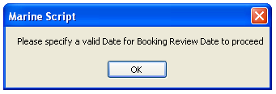
Figure 18

Click the “OK” button to close the message window.

  - Please specify a valid Date for Retention Line Date to proceed

This message is displayed when the user clicks on the “Next >” button of “Agent Contact and Ticket Deadline” screen/form, if the “Retention Line Date” text box is blank, or does not contain a valid date, or is not in the DDMMM format.

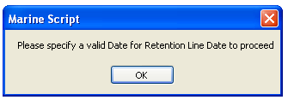
Figure 19

Click the “OK” button to close the message window.
  - City, Agent, Consultant and Telephone together cannot be greater than 51 characters.

This message is displayed when the user clicks on the “Next >” button of “Agent Contact and Ticket Deadline” screen/form, if the total number of characters for “City“, “Agent”, “Consultant” and “Telephone” text boxes combined is greater than 51 characters.

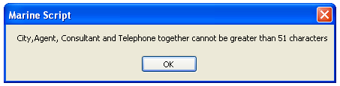
Figure 20

Click the “OK” button to close the message window.

  - Command:<%Command description%>
Error message :<%Host response lines.%>

This message is displayed when the user clicks on the “Next” button on the “Passenger and Contact Information” screen/form or “Flight Segment Information” Screen/form or “Agent Contact and Ticket Deadline” screen/form or “End Transaction or Ignore” screen/form, and an error message was returned by the host during the command execution.

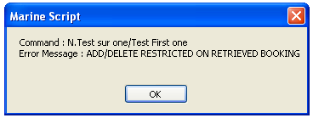
Figure 21

Click the “OK” button to close the message window and exit the application

Functionality details

When an agent clicks on the Marine Script icon in the custom toolbar the script will perform the following tasks:

- If the user is not signed in the Galileo Desktop, the screen to ‘Select No. of Passengers and Information Source’ will not display and the script will close.

- If the user is signed in the Galileo Desktop, the screen to ‘Select No. of Passengers and Information Source’ will be display.

  - Select No. of Passengers and Information Source Screen/Form

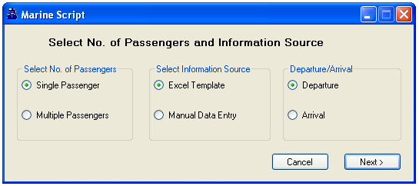
Figure 22
- On the screen above (Figure 22) there are three sections titled “Select No. of Passengers”, “Select Information Source” and “Departure / Arrival”. The options “Single Passenger”, “Excel Template” and “Departure" are automatically selected as default.

- The “Departure / Arrival” radio button group is enabled only when the “Excel Template” radio button is selected in the “Select Information Source” radio button group.
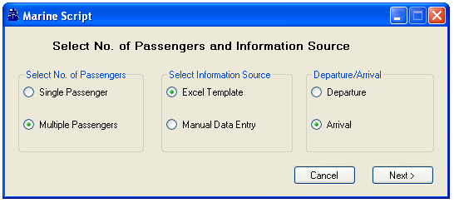
Figure 23

- If the “Manual Data Entry” radio button is selected in the “Select Information Source” radio button group, the “Departure / Arrival” radio button group is automatically disabled.
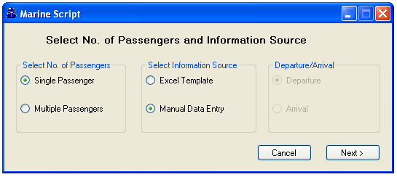
Figure 24
- If the user clicks on the “Cancel” button, the screen will close and the application exited.

- If the “Excel Template” radio button is selected in the “Select Information Source” radio button group and the user clicks on the ‘Next’ button, the "Select Excel Template" screen/form will appear.

- If the “Manual Data Entry” radio button is selected in the “Select Information Source” radio button group and the user clicks on the ‘Next’ button, then based on the number of selected passengers, the "Passenger and Contact Information" screen will appear and display the applicable number of rows/passengers.

  - Select Excel Template screen/form

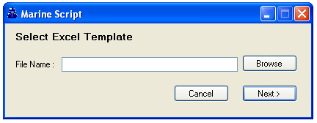
Figure 25
- The user will be able to type in the filename and path of the excel file in the “Filename:” text box. By default the Filename text box should be blank.

- If the user clicks on the “Next >” button and the “Filename :” text box is blank, the script will display the following error message “Please specify or select an excel sheet to proceed”. If the user selects ‘OK’, the script will do nothing.

- If the user clicks on the “Next >” button and the Path specified in the “Filename :” text box is invalid or the file does not exist or the application is not able to open the file, the script will display the following error message:
“The specified excel sheet is invalid / corrupt or does not exist at the specified path. Please check the filename or path and try again” if the user selects ‘OK’ the script will do nothing.

- When the user clicks on the “Browse” button, an Open file dialog box opens with the title "Please select a file". The user will be able to select only excel files. The path of the file selected by the user will display in the "Filename : " text box.

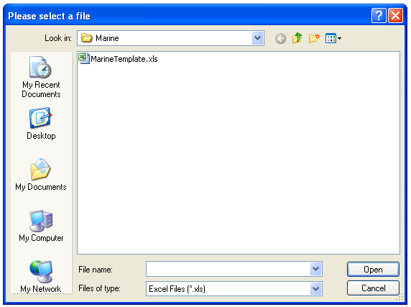
Figure 26

- If the user clicks on the “Cancel” button, the form will close and the application exited.

- When the user clicks on the “Next >” button, then on the basis of "select No.of Passengers" radio button group, "Passenger and ContactInformation" screen will be displayed.

  - Passenger and Contact Information– Single Passenger screen/form

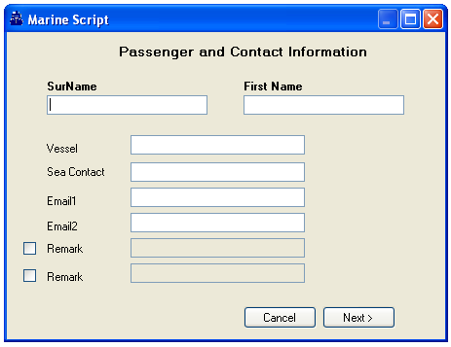
Figure 27
- If the user selects the “Manual Data Entry” radio button on Select No. of Passengers and Information Source Screen/Form, all the text boxes on the form will be blank.

- If the user has selected an "excel template" radio button on Select No. of Passengers and Information Source Screen/Form, then the corresponding values from the excel template will be populated in the text boxes.
If there is more then 1 passenger specified in the excel template, then only the information for the first passenger will be populated.

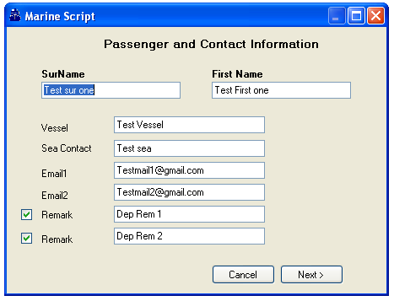
Figure 28

- By default the maximum number of characters for Surname is 53 and for First Name 52. So If the length of the value from the excel template for the Surname is greater than 53 characters, then only select the first 53 characters. If the length of the value from the excel template for the First name is greater than 52 characters, then only select the first 52 characters.

- If the length of the “Vessel” value from the excel template is greater than 180 characters, then only select the first 180 characters.

- If the length of the “Sea Contact” value from the excel template is greater than 180 characters, then only select the first 180 characters.

- If the length of the “Email 1" and "“Email 2" value from the excel template is greater than 125 characters, then only select the first 125 characters.

- By default both the check boxes will be unchecked and the text boxes will be blank and disabled for "Remark".

- The Remark text box will be enabled when the corresponding check box is ticked. When the check box is un-ticked, the corresponding text boxes will be cleared and disabled.

- The Remark text box will be enabled when the corresponding check box is ticked. If the user has selected an excel template, then the corresponding value from the excel template will be populated in the text boxes and the corresponding check box will be ticked.

- When a user clicks on the “Next >” button and the “Surname” text box is blank, the following error message will display: “Please specify a Surname to proceed”. If the user clicks on the OK button, the script will do nothing

- When the user clicks on the “Next >” button and the “First name” text box is blank, the following error message will display: “Please specify a First Name to proceed”. If the user clicks on the OK button the script will do nothing.

- When the user clicks on the “Next >” button and the total number of characters for the “Surname“ and “First Name” text boxes is greater than 54 characters, the following error message will display: “The Surname and First Name together cannot be greater than 54 characters.” If the user clicks on the OK button the script will do nothing.

- When the user clicks on the “Next >” button and the “Vessel” text box is blank, the following error message will display: “Please specify a Vessel to proceed”. If the user clicks on the OK button the script will do nothing.

- When the user clicks on the “Next >” button and the check box for any of the Remark field are ticked but the remark field are blank, the following error message will display: “Please specify a value for the selected Remark field or uncheck the check box”. If the user clicks on the OK button the script will do nothing.

- When the user clicks on the “Next >” button and there is a value in the “Email1” or “Email2” text boxes, the script will validate whether the email addresses entered contain the symbols “@” and “.”. If not, the following error message will display: “Please specify a valid email address to proceed”. If the user clicks on the OK button the script will do nothing.

- If the user clicks on the “Cancel” button, the form will close and the application exited.

- At this stage, when the user clicks on the “Next” button, the script validates all the relevant information (SurName/Firstname, Vessel, Sea Contact, Email1, Email2, Remark1, Remark20 and once executed successfully, the Flight Segment Information screen/form will be displayed.

- If an error occurs during the execution of the script, an error message will be displayed to the user with the option to click on ‘OK’ to exit the script.

Figure 29

- All commands executed by the script are also executed on an active Focal point window and Viewpoint window. Please note that the Focalpoint active window only displays the last command executed by the script.

  - Passenger and Contact Information– Multi Passenger screen/form

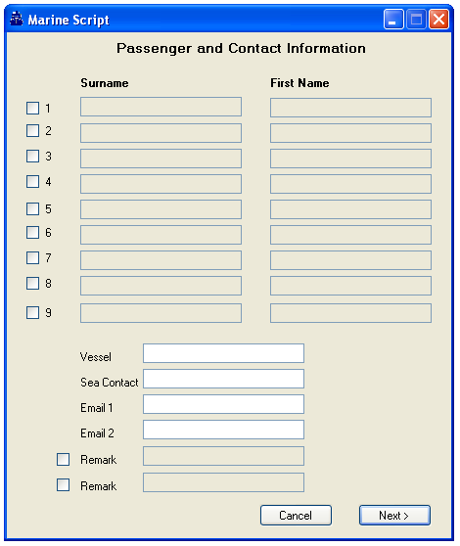
Figure 30

- If the “Manual Data Entry” option is selected, all the text boxes on the ‘Select No. of Passengers and Information Source’ Screen/Form will be blank.

- If the "Excel Template" option is selected, the corresponding text boxes on the ‘Select No. of Passengers and Information Source’ Screen/Form will be populated with the values from the excel template and the check boxes will be ticked.

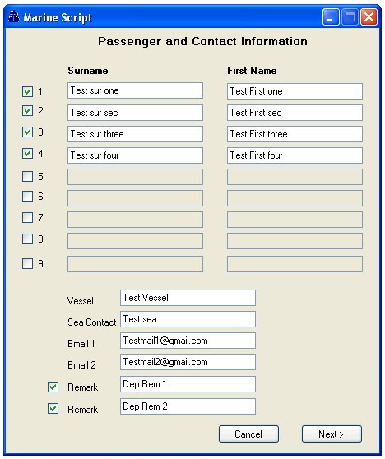
Figure 31
- Ticking a text box will enable the corresponding Surname and First name fields. Un-ticking it will clear the fields and disable it.

- By default the maximum number of characters for Surname is 53 and for First Name 52. So If the length of the value from the excel template for the Surname is greater than 53 characters, then only select the first 53 characters. If the length of the value from the excel template for the First name is greater than 52 characters, then only select the first 52 characters.

- If the length of the “Vessel” value from the excel template is greater than 180 characters, then select only the first 180 characters.

- If the length of the “Sea Contact” value from the excel template is greater than 180 characters, then select only the first 180 characters.

- If the length of the “Email 1" and "“Email 2" value from the excel template is greater than 125 characters, then select only the first 125 characters.

- By default both the check boxes will be unchecked (un-ticked) and the text boxes will be blank and disabled for "Remark".

- The Remark text box will be enabled when the corresponding check box is ticked. When the check box is un-ticked, the corresponding text boxes will be cleared and disabled.

- The Remark text box will be enabled when the corresponding check box is ticked. If the user has selected an excel template, then the corresponding value from the excel template will be populated in the text boxes and the corresponding check box will be ticked.

- When a user clicks on the “Next >” button and the “Surname” text box is blank, the following error message will display: “Please specify a Surname to proceed”. If the user clicks on the OK button, the script will do nothing

- When the user clicks on the “Next >” button and the “First name” text box is blank, the following error message will display: “Please specify a First Name to proceed”. If the user clicks on the OK button the script will do nothing.

- When the user clicks on the “Next >” button and the total number of characters for the “Surname“ and “First Name” text boxes is greater than 54 characters, the following error message will display: “The Surname and First Name together cannot be greater than 54 characters.” If the user clicks on the OK button the script will do nothing.

- When the user clicks on the “Next >” button and the “Vessel” text box is blank, the following error message will display: “Please specify a Vessel to proceed”. If the user clicks on the OK button the script will do nothing.

- When the user clicks on the “Next >” button and the check box for any of the Remark field is ticked but the remark field is blank, the following error message will display: “Please specify a value for the selected Remark field or uncheck the check box”. If the user clicks on the OK button the script will do nothing.

- When the user clicks on the “Next >” button and there is a value in the “Email1” or “Email2” text boxes, the script will validate whether the email addresses entered contain the symbols “@” and “.”. If not, the following error message will display: “Please specify a valid email address to proceed”. If the user clicks on the OK button the script will do nothing.

- If the user clicks on the “Cancel” button, the form will close and the application exited.

- At this stage, when the user clicks on the “Next” button, the script will validate the data is correct (ie SurName/Firstname, Vessel, Sea Contact, Email1, Email2, Remark1, Remark2) and once all commands are successfully executed, the Flight Segment Information screen/form will be displayed.

- If an error occurs whilst the script is running, an error message will be displayed to the user in a message box with an OK button. Click on the OK button to exit the script.

Figure 32

- The commands executed by the script are active in the Focal point window and Viewpoint window. Please note that the Focal point active window will only display the last command executed by the script.

  - Flight Segment Information screen/form

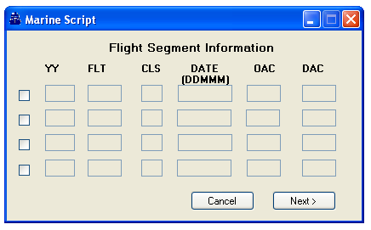
Figure 33
- By default this form/screen has all check boxes un-ticked and the corresponding the text boxes blank and disabled.

- If the current booking file contains any air segments, the air segment information will automatically populate in the corresponding text boxes, with each row representing one segment.
If there are more then 4 air segments present in the booking file, only the information for the first 4 air segments will display.
The check boxes with corresponding text boxes containing values will be ticked. All text boxes and check boxes will be disabled.

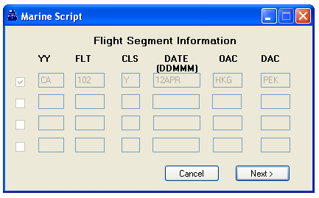
Figure 34
- The text boxes in a row will be enabled only when the corresponding check box for that row has been ticked. If the user un-ticks the check box, the corresponding text boxes will be cleared and disabled.

- When a user clicks on the “Next >” button for all ticked check boxes and the corresponding “YY” / “FLT”/ “CLS” / “DATE” / “OAC” / “DAC” text boxes are blank, the following error message will display: “You have not specified a value for a flight segment. Please specify a value to proceed”. If the user clicks on the OK button, the script will do nothing.

- When a user clicks on the “Next >” button and there is no check box for any Flights ticked, the following error message will display: “Please add at least one flight segment to proceed”. If the user clicks on the OK button the script will do nothing.

- When a user clicks on the “Next >” button with every check box ticked and the corresponding “DATE” text box does not contain a valid date or is not in the DDMMM format, the following error message will display: “Please specify a valid DATE to proceed”. If the user clicks on the OK button the script will do nothing.

- When the values for the air segments are populated from the current booking file, no validation will be performed as all check boxes and text boxes are disabled and non editable.

- If the user clicks on the “Cancel” button, the form will be closed and application exited.

- At this stage, when the user clicks on the “Next” button, the script will validate the segment information data is correct and once all commands are successfully executed, the ‘Agent Contact and Ticketing Deadline screen/form will be displayed.

- If an error occurs whilst the script is running, an error message will be displayed to the user in a message box with an OK button. Click on the OK button to exit the script.

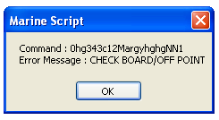
Figure 35

- The commands executed by the script are active in the Focal point window and Viewpoint window. Please note that the Focal point active window will only display the last command executed by the script

  - Agent Contact and Ticket Deadline screen/form

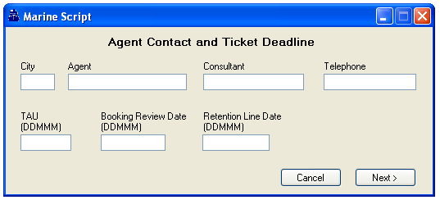
Figure 36

- All the text boxes will be blank and enabled by default.

- In any subsequent execution of the application, the value specified in the previous execution would be populated in "City", "Agent",“Consultant” and “Telephone” automatically. from MarineAgent.xml file.

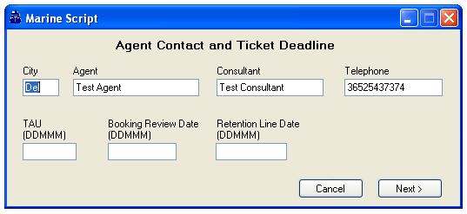
Figure 37
- Max length for "city” is 3 characters.

- Max length for “Consultant” and "Telephone" is 46 characters

- Max length for “TAU (DDMMM)” ,“Booking Review Date (DDMMM)” and “Retention Line Date (DDMMM)” is 5 characters each

- When a user clicks on the “Next >” button and the “City” text box is blank, the following error message will display: “Please specify a value for City to proceed”. If the user clicks on the OK button the script will do nothing.

- When a user clicks on the “Next >” button and the “Agent” text box is blank, the following error message will display: “Please specify a value for Agent to proceed”. If the user clicks on the OK button the script will do nothing.

- When a user clicks on the “Next >” button and the “Consultant” text box is blank, the following error message will display: “Please specify a value for Consultant to proceed”. If the user clicks on the OK button the script will do nothing.

- When a user clicks on the “Next >” button and the “Telephone” text box is blank, the following error message will display: “Please specify a value for Telephone to proceed”. If the user clicks on the OK button the script will do nothing.

- When a user clicks on the “Next >” button and the total number of characters for the “City“, “Agent”, “Consultant” and “Telephone” text boxes is greater than 51 characters, the following error message will display: “City, Agent, Consultant and Telephone together cannot be greater than 51 characters.” If the user clicks on the OK button the script will do nothing.

- When a user clicks on the “Next >” button and the “TAU” text box is blank, does not contain a valid date or is not in the DDMMM format, the following error message will display: “Please specify a valid Date for TAU to proceed”. If the user clicks on the OK button the script will do nothing.

- When a user clicks on the “Next >” button and the “Booking Review Date” text box is blank, does not contain a valid date or is not in the DDMMM format, the following error message will display: “Please specify a valid Date for Booking Review Date to proceed”. If the user clicks on the OK button the script will o nothing.

- When a user clicks on the “Next >” button and the “Retention Line Date” text box is blank, does not contain a valid date or is not in the DDMMM format, the following error message will display: “Please specify a valid Date for Retention Line Date to proceed”. If the user clicks on the OK button the script will do nothing.

- If the user clicks on the “Cancel” button, the form will be closed and the application exited.

- At this stage, when the user clicks on the “Next” button, the script will validate the data is correct (ie City,Agent, Consultant, Telephone, TAU, Booking Review Date, Retention Line Date) and once all commands are successfully executed, the ‘End Transaction or Ignore” screen/form will be displayed.

- If an error occurs whilst the script is running, an error message will be displayed to the user in a message box with an OK button. Click on the OK button to exit the script.

Figure 38

- The commands executed by the script are active in the Focal point window and Viewpoint window. Please note that the Focal point active window will only display the last command executed by the script

- If the user clicks on the “Next >” button and all validation are completed and correct, the End Transaction or Ignore screen/form will display.

  - End Transaction or Ignore screen/form

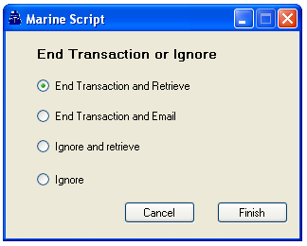
Figure 39

- “End Transaction and Retrieve” is selected by default.

- The “End Transaction and Email” option will be disabled if no value for Email 1 or Email 2 have been specified.

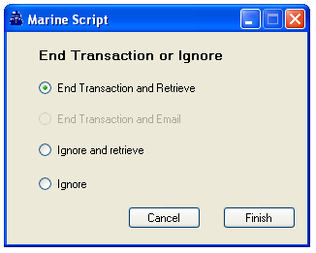
Figure 40
- On this form, if the user clicks on the “Cancel” button, the form will close and the application exited.

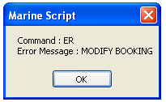
Figure 41

On this form when the user clicks on the “Finish >” button and based on the selected option, the booking file will End Transaction.

- If any error message is returned by the host, it will be displayed to the user in a message box with an OK button. Click on the OK button to exit the script.

Figure 42

Appendix
  - Mandatory Marine data

To execute the Marine Script, users have to be signed in Galileo Desktop 1.0 or Galileo desktop 2.x.

Copyright
©2009 Travelport Inc. All rights reserved. [insert list of trademarks used in document] are registered trademarks or trademarks of Travelport Inc. and/or its affiliates in the United States and/or other countries. Other trademarks are property of their respective owners.

Notes About Examples
All screen examples and other inserts associated with system output are provided for illustration purposes only. They are provided as illustrative examples of system functionality and are not meant to represent actual screen responses, rates, etc.

Note to document author: If the document contains confidential information, each page of the document should be marked with “TRAVELPORT CONFIDENTIAL” in the footer.

